

**Rajiv Gandhi Government College, Saha (Ambala)**

(Affiliated to Kurukshetra University Kurukshetra)

**Criteria**

**Feed back report of alumni and analysis of report**

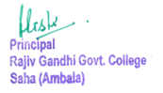

Feed back report of Alumni( Excel Sheet Report)

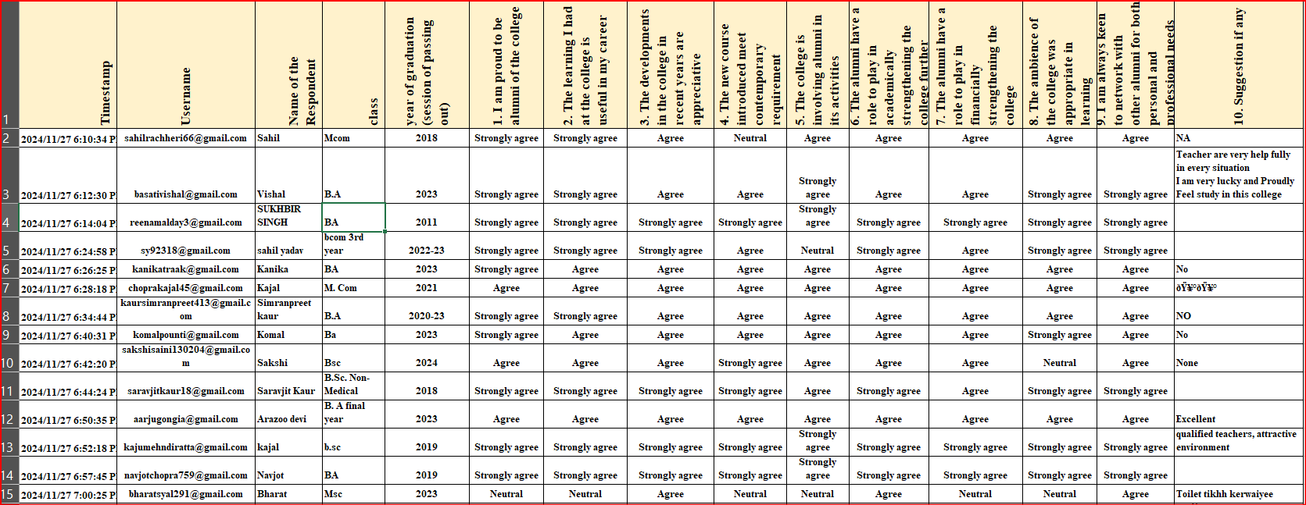

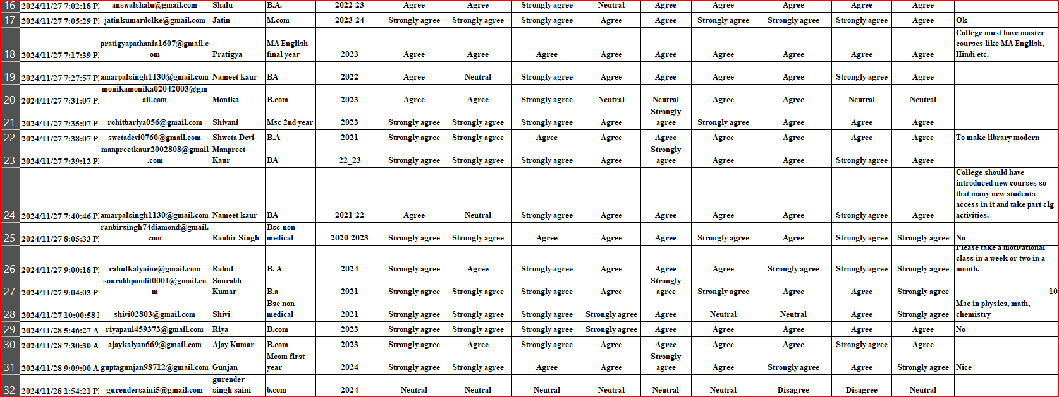

Feed back report of Alumni( Excel Sheet Report)

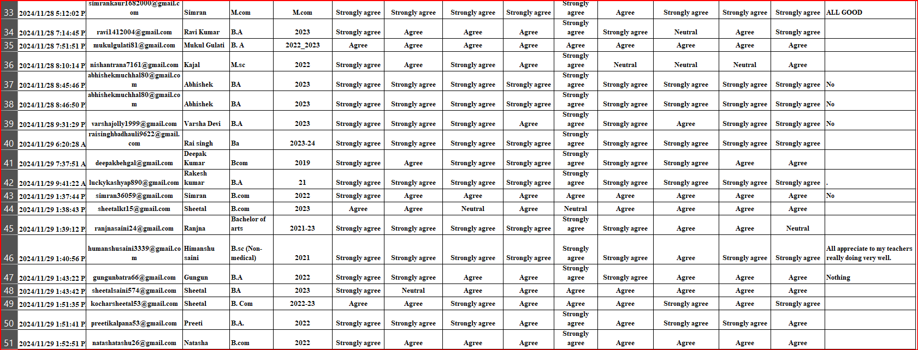

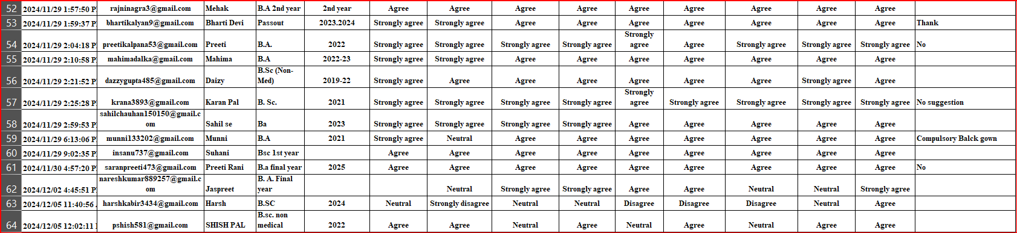

SCREEN SHOTS OF GOOGLE FORM

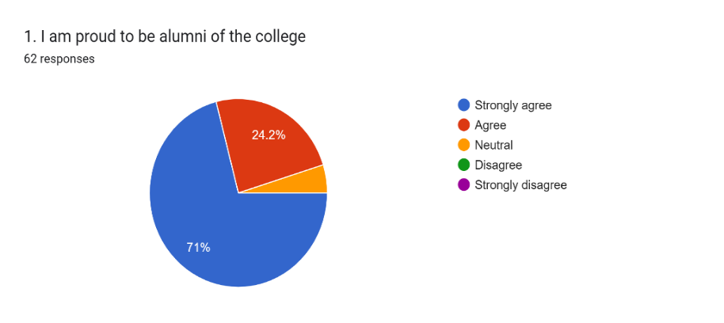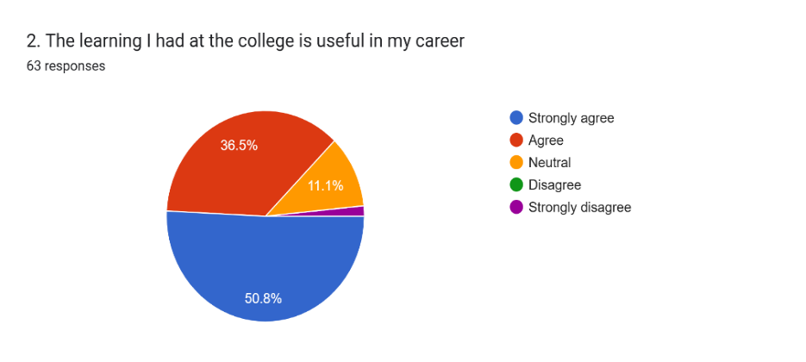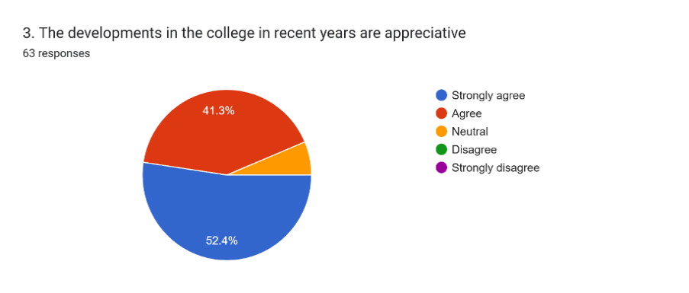 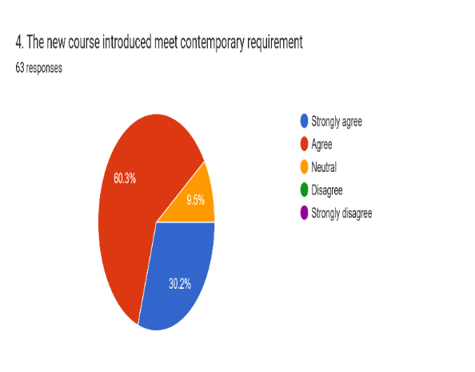

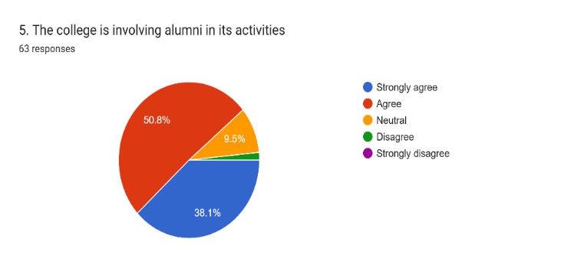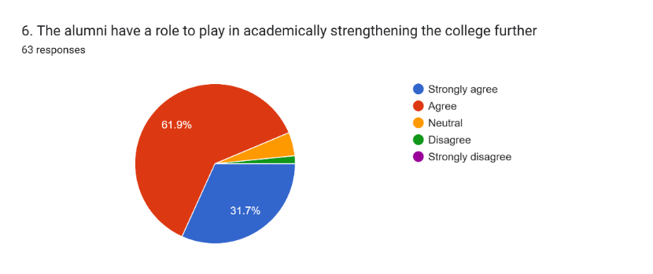

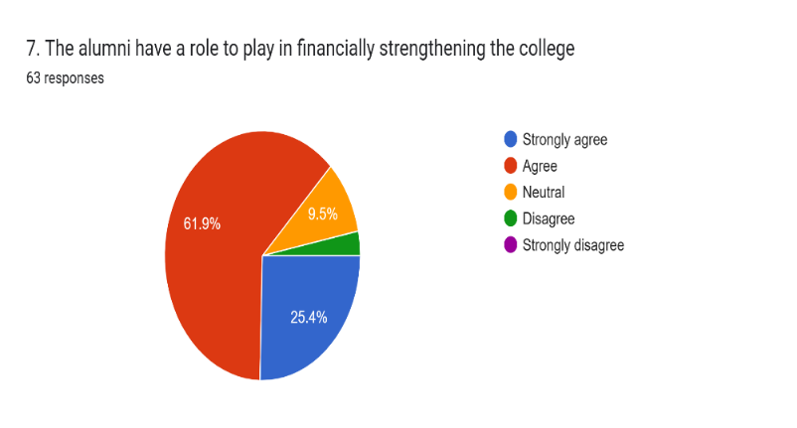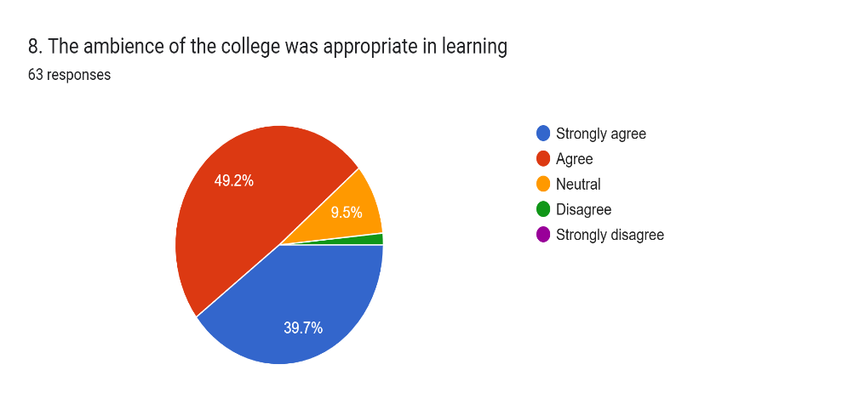

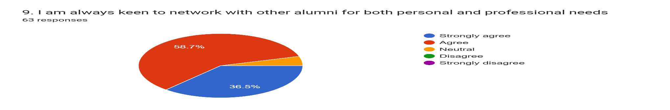

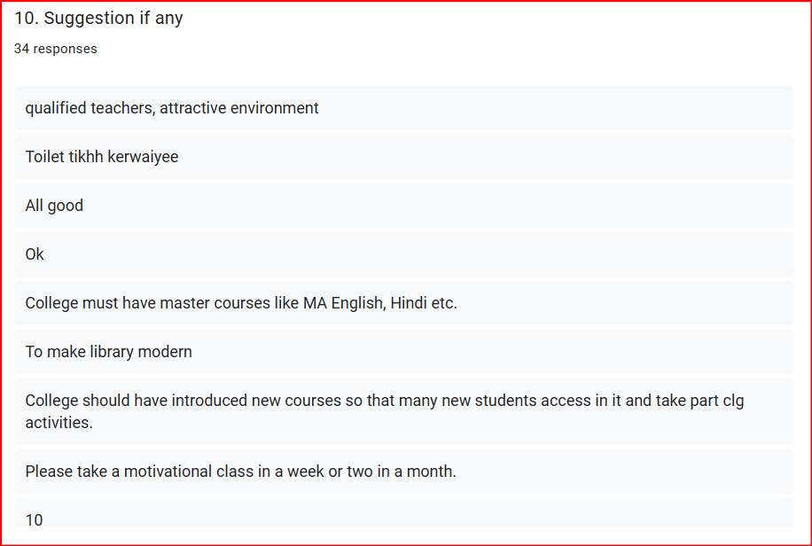

**RAJIV GANDHI GOVT. COLLEGE SAHA (AMBALA)**

**Analysis of feedback received from Alumni**

|  |  |  |  |  |  |
| --- | --- | --- | --- | --- | --- |
| **STATEMENT** | **STRONGLY AGREE** | **AGREE** | **NEUTRAL** | **DISAGREE** | **STRONGLY DISAGREE** |
| **1. I am proud to be alumni of the college** | **44** | **15** | **3** | **-** | **-** |
| **2. The learning I had at the college is useful in my career** | **32** | **23** | **7** | **1** | **-** |
| **3. The developments in the college in recent years are appreciative63 responses** | **33** | **26** | **4** | **-** | **-** |
| **4. The new course introduced meet contemporary requirement** | **19** | **38** | **6** | **-** | **-** |
| **5. The college is involving alumni in its activities** | **24** | **32** | **6** | **1** | **-** |
| **6. The alumni have a role to play in academically strengthening the college further.** | **20** | **39** | **3** | **1** | **-** |
| **7. The alumni have a role to play in financially strengthening the college.** | **16** | **39** | **6** | **2** | **-** |
| **8. The ambience of the college was appropriate in learning63 responses** | **25** | **31** | **6** | **1** | **-** |
| **9. I am always keen to network with other alumni for both personal and professional needs** | **23** | **37** | **3** | **-** | **-** |

**RAJIV GANDHI GOVT. COLLEGE SAHA (AMBALA)**

**Analysis of feedback received from Alumni**

**The table summarizes the feedback received from alumni regarding the institution's curriculum, academic performance, and overall environment. Alumni provided their responses on a 5-point scale ranging from strongly agree to strongly disagree. Key insights from the feedback are as follows:**

1. A significant 95% of alumni feel proud to be associated with the institution, reflecting a strong emotional and professional connection. Only 5% of respondents were undecided.
2. Approximately 87% of alumni believe that the knowledge and skills acquired during their time at the college have been useful in their careers, showcasing the practical impact of the curriculum. About 11% remained neutral, while 2% disagreed.
3. Around 94% of alumni appreciate the recent progress and initiatives undertaken by the institution, indicating satisfaction with its evolution. Meanwhile, 9% of respondents were neutral.
4. Nearly 90% of alumni feel that the new courses introduced align well with contemporary industry and academic requirements. However, 10% were undecided.
5. About 89% of respondents agreed or strongly agreed that alumni play an active role in college activities, highlighting their continued engagement. Only 10% remained neutral and 1% disagreed.
6. Approximately 94% of alumni believe they can contribute significantly to academically strengthening the college, reflecting a sense of responsibility toward its development. However, 4.8% were undecided, and 1.6% disagreed.
7. Around 87% of respondents acknowledged their potential to contribute financially to the institution. A notable 10% were undecided, and only 3% disagreed, suggesting room for more awareness or initiatives.
8. About 89% of alumni agree that the college provided an appropriate environment for learning, supporting academic and personal growth. Around 10% were undecided on this matter and only 1% disagreed.
9. Approximately 96% of alumni expressed willingness to network with fellow alumni for personal and professional benefits. Around 4% were neutral.